Travis Waggoner

Southern New Hampshire University

CS-360

05/29/2022

UI Design

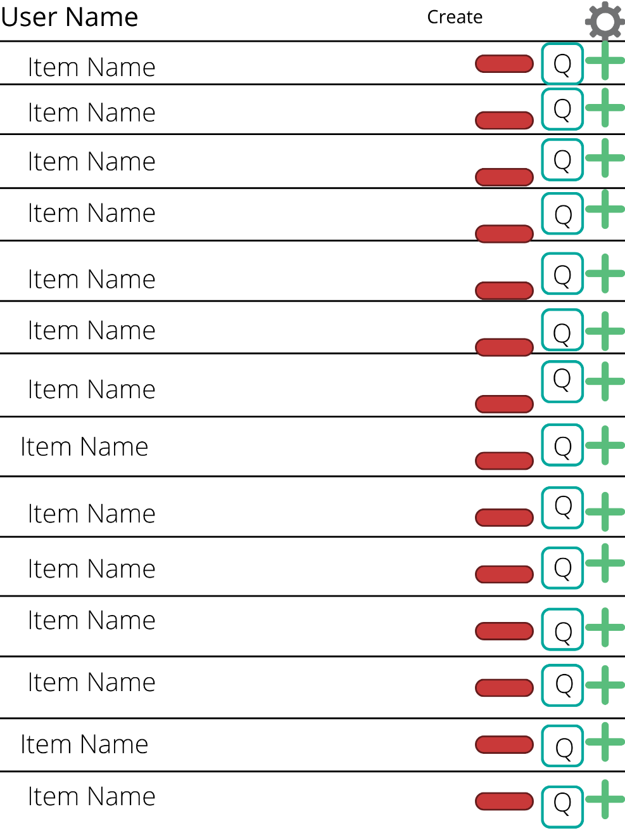

Legend

* Red minus subtracts from quantity
* Green plus adds to quantity
* Q is the quantity of the item
* The wheel is the settings
* Create opens a menu to create an item

Interactive

The plus and minus buttons will be interactive so the user can add or remove quantity of items. The quantity will change as the user changes the amount. The create button will allow the user to add a new item with a prompt. The username is not interactive and is only there for informational purposes. The quantity is not in itself interactive it is information for the user. The setting button will bring up the setting prompt.

Justification

I chose this UI design because it is the most logical for the user. The icons were shown this way because they are icons that are normally utilized with in many systems and the user would understand there uses. The quantity would be in the largest numbers that the boxes would allow for the system to display the text in a large enough format. This logic would also follow for the item names as well. The user is displayed at the top to allow the user to know who is logged in, allowing for one system to be utilized with many users. The settings will allow the user to change and edit settings as well as log out.